🚀 Installed Jenkins on Google Cloud Platform (GCP)!
Another step forward in my learning journey!
Today, I worked on setting up Jenkins on an Ubuntu 24.04 LTS virtual machine running on Google Cloud Platform.
🔧 What I worked on:
1.Created and accessed an Ubuntu VM on Google Cloud.
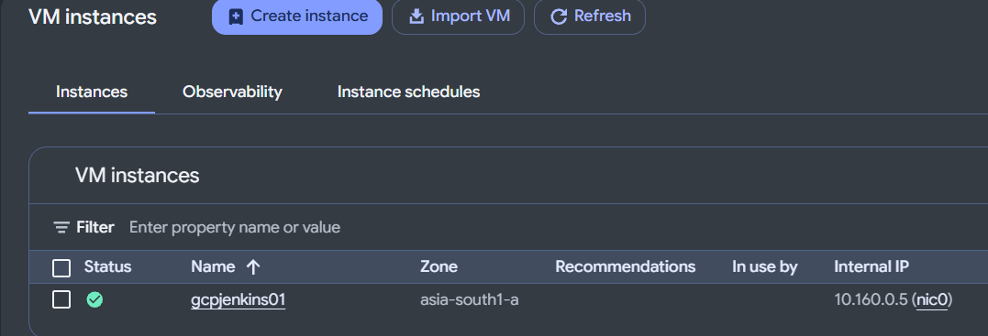
2.Updated Ubuntu package repositories using apt update.
Step 1: Add the Jenkins repository
Run these commands one by one:
sudo wget -O /etc/apt/keyrings/jenkins-keyring.asc \
https://pkg.jenkins.io/debian-stable/jenkins.io-2026.key
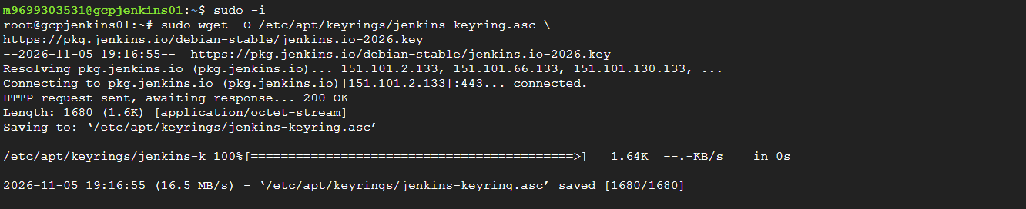
NOTE:
If that key URL fails, use the current installation instructions from the official Jenkins documentation rather than importing an unverified key.
Add the repository:
echo "deb [signed-by=/etc/apt/keyrings/jenkins-keyring.asc] https://pkg.jenkins.io/debian-stable binary/" | sudo tee /etc/apt/sources.list.d/jenkins.list > /dev/null
3.Installed Fontconfig and OpenJDK 21.
sudo apt update
sudo apt install fontconfig openjdk-21-jre
java -version
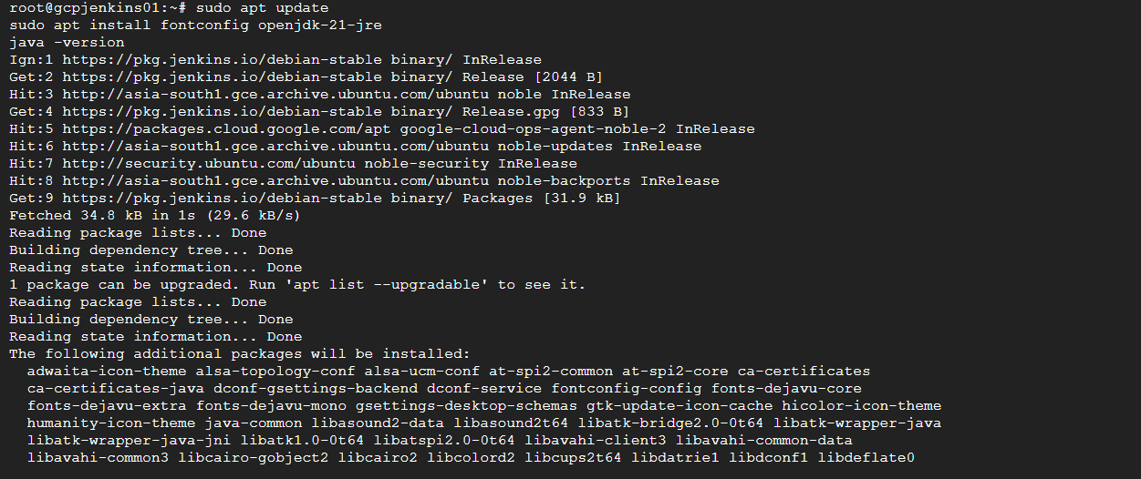
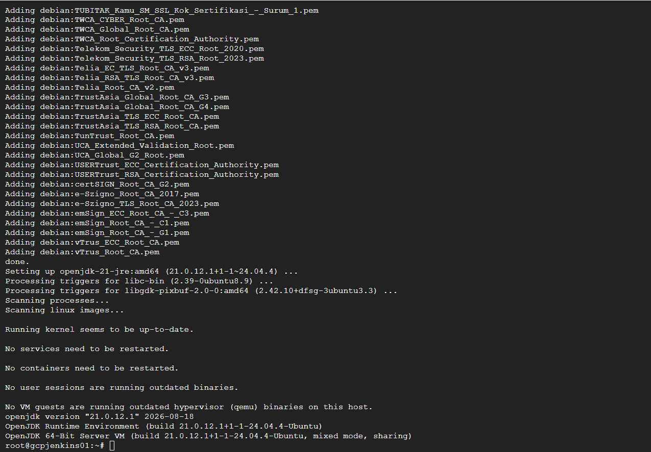
4.Configured and installed Jenkins.
sudo apt update
sudo apt install jenkins -y
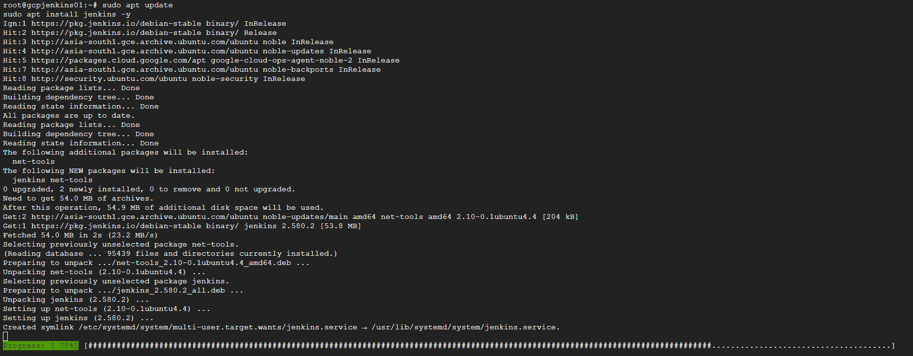
5.Enabled and started Jenkins using systemctl.
sudo systemctl enable jenkins
sudo systemctl start Jenkins
6.Verified the Jenkins service status.
sudo systemctl status Jenkins
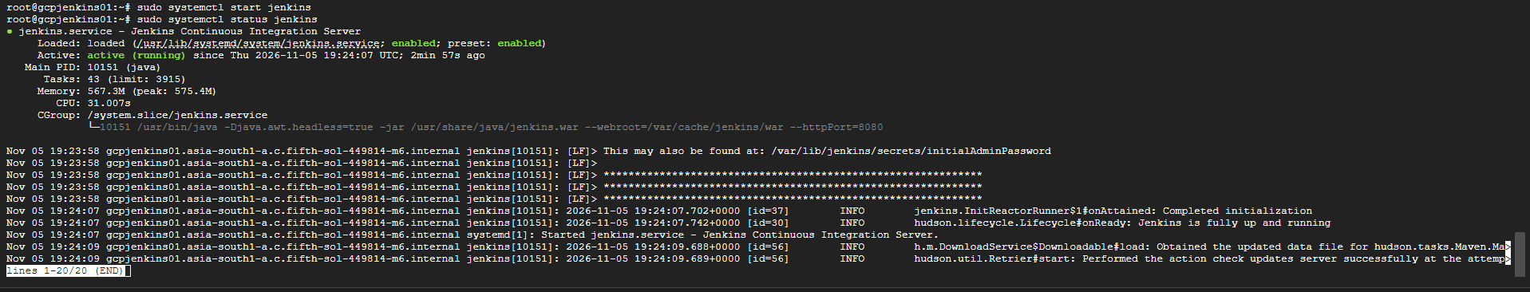
7: Prepared Jenkins for initial configuration through the web interface.
Open this in your browser:
http://YOUR_VM_EXTERNAL_IP:8080
Note: Default port for Jenkins is 8080
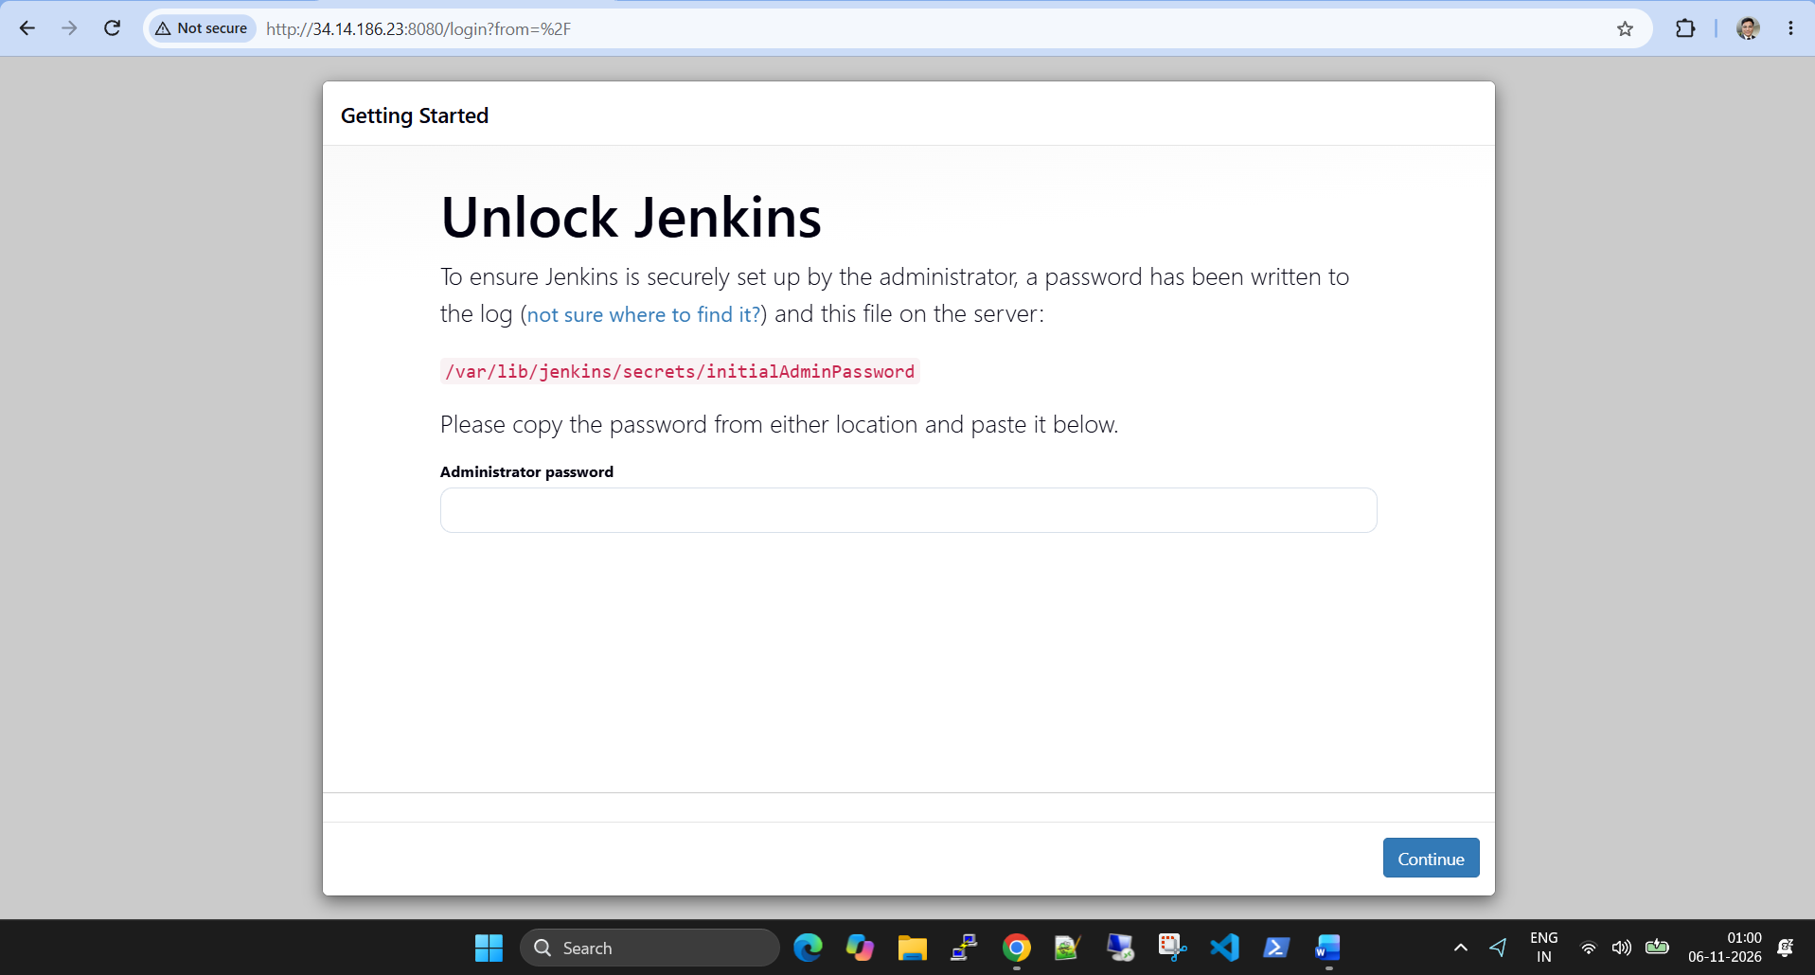
Get the initial administrator password:
sudo cat /var/lib/jenkins/secrets/initialAdminPassword
Then: Copy the password and paste it into the Jenkins setup page.
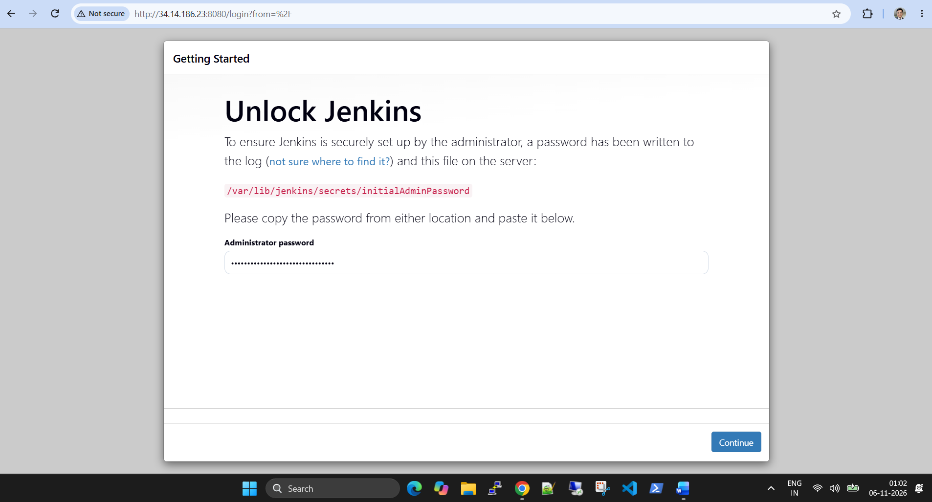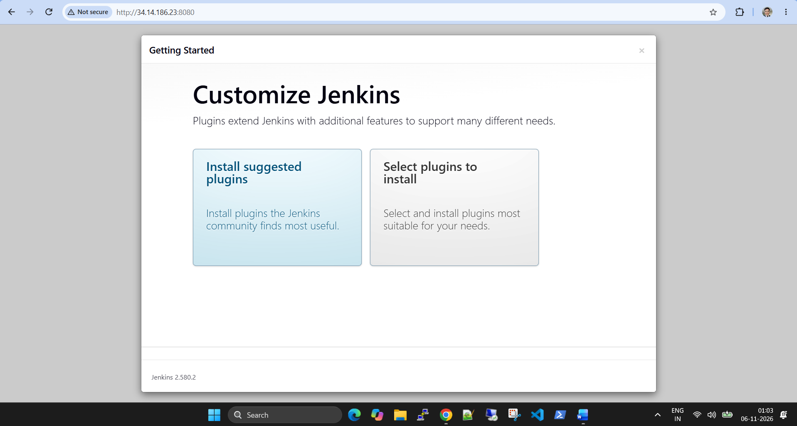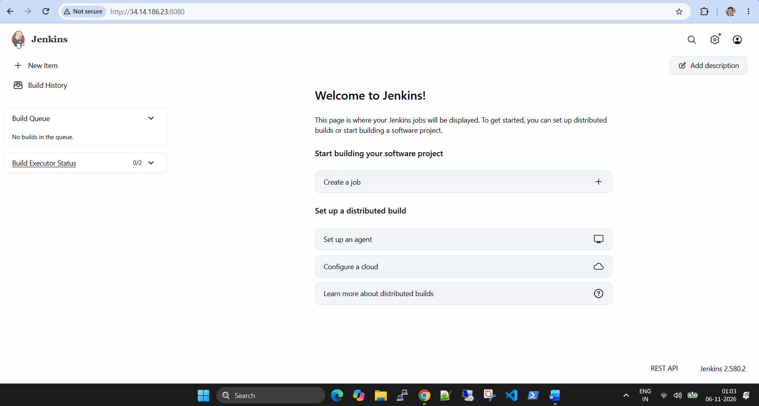
💡 Key learnings:
Understanding Jenkins prerequisites and Java compatibility.
Managing Linux services using systemd.
Understanding Jenkins service management.
Learning how cloud firewall rules control access to applications.
This helps Setting up the foundation for CI/CD automation.
🎯 What's next?
My next goal is to configure a Jenkins pipeline, integrate it with GitHub, and automate application builds and deployments.
1. GitHub Integration: You’ll likely want to install the "GitHub Integration" plugin in Jenkins (under Manage Jenkins → Plugins) and create a Personal Access Token (PAT) from GitHub to authenticate Jenkins with your repository.
2. First Pipeline: Try creating a simple "Hello World" pipeline script (Jenkinsfile) first, then move to building a simple app (like a Java or Python project) to understand the build, test, and deploy stages.
3. Firewall Rules: Since you’re running on GCP, ensure your VM’s firewall allows inbound traffic on port 8080 so you can access the Jenkins UI from outside your network.
#Jenkins #DevOps #GoogleCloud #GCP #CICD #Linux #Ubuntu #OpenJDK #CloudComputing #ContinuousIntegration #ContinuousDelivery #LearningByDoing

